Dr. Wilding
Styles and Analysis II
Emma Donkin
May 1st, 2020
Schubert and Scarlatti: A Discussion of Sonatas
When researching the lyricism of classical era music, I could think of no better work to discuss than the tender first movement of Franz Schubert’s Piano Sonata in A major (D 664). In contrast, when I sought out a baroque work to contrast this piece, I was expecting to find a work full of contrapuntal rigidity; instead of rigidity, I found Domenico Scarlatti’s Keyboard Sonata in B minor (K.27), a work full of flowing lines and lyricism in addition to contrapuntal nuance and rhythmical exuberance. Schubert’s Sonata in A major, D 664, was composed in 1819 and dedicated to Josephine von Koller of Austria. Composed in the late classical era, the piano walks the line between traditional classicalism and romanticism; coupling expressive flowing lines with powerful chordal passages, the piece encapsulates the best of the late classical and early romantic eras. The lyrical themes seem to reflect Schubert’s feelings toward this woman, whom he considered to be a great pianist as well. Domenico Scarlatti’s Sonata in B minor K.27, is a reflection of Scarlatti’s early works. While not widely published until much later, it appeared in 1738, and is estimated to have been written up to 1-2 decades beforehand. While both pieces are sonatas, they differ greatly in form and style; however, both contain lyrical melodies and beautiful stylings that embody the greatness of their composers.
In Schubert’s Piano Sonata in A major (Fig. 1.1), we begin the first movement, Allegro Moderato, with an almost playful melody. The pickup serves to provide interest and grab the listener’s attention before the left hand joins in, and continues to hold that attention as the melody meanders down to the octave E. The first eight bars of the subject continue in A, but briefly tonicize B minor for a measure in bars 5 and 6 by using a fully-diminished 7 chord in bar 5; we can interpret as a vii⁰⁷/vi chord, as A#dim. is outlined and resolves to B minor. We quickly return to A, resolving on I in bar 8. Following this, Schubert decides to provide a brief moment of tonal contrast, shifting slightly to F# minor until we return to the first half of the initial theme in A major at bar 13. As our return to the first subject winds down, Schubert chooses to repeat the bar containing the rogue fully-diminished 7th chord, in order to give us more depth and meaning to that particular passage.
The transition begins at bar 20 with a lovely triplet figure in the right hand that floats us up to a new register. It seems, at first, as though Schubert intends to repeat the first subject in this new register, as we daintily land on a high E to begin the second subject (S1). However, it quickly becomes clear that Schubert is using our assumptions against us for our own musical enjoyment; the music morphs into E major, which is cemented in the score in bar 25 as the melody outlines a E major triad. E is further tonicized in bar 28, as the bass emphasizes the A, B, then E on beats 1, 2 and 3 (in other words, a IV V I progression is highlighted in the bass). In bars 28-29, it seems that we move abruptly back to A major; while E is emphasized in bars 32-33, E actually functions as a dominant harmony, as evidenced by the sudden change to A minor in bar 34. However, as we analyze further along the linear score, we discover that the A minor carries us back to E minor; the A minor is now functioning as a predominant of E minor. I consider S2 to begin on the A minor chord, as we are now introduced to new material in a slightly different key (E minor). We must also pay close attention to the bass in bars 36-39, which not only contain fragments of the original P1 melody, but also walk us down chromatically from A to B, allowing for an entire array of harmonies overtop as we shift back to E major. The closing zone begins at bar 42, and the expositional material ends at the repeat sign on an E major chord, and functions as a dominant to the return of the A major opening.
The developmental section of the Schubert sonata in A major begins by roughly tonicizing F-sharp minor, using a vii⁰⁷ chord against a modification of the P1 opening melody to create tension. The melody, instead of ending on “sol” immediately after the pickup, lands on “fa” instead, filling out the vii⁰⁷ chord and resulting in an unsettling displacement of the original joyful theme. In bars 52-56, Schubert also uses fragments of the dotted-quarter sixteenth-note theme in the bass, allowing for a call-and-response section as the dominant harmony is prolonged. The dominant, held and emphasized in bar 56, resolves in bar 57 with a nod to the transitional triplet melody from the exposition, now a brash octave run in the bass instead of a light, lyrical melody in the upper register. Throughout the development, Schubert borrows material from several areas of the exposition, though not necessarily in a linear order. For instance, he borrows the repeated Es in bars 65-66 (and again at 71-72) from the closing zone of the exposition much earlier on in the development compared to where this material came in during the exposition. Schubert chooses to continue to extrapolate the brief transitional triplets from the exposition in the development, and uses them to modulate from F-sharp minor to G major, then to D major, then to F-minor, and finally using a F7 chord in bar 64 in the left hand as an almost Neopolitan chord to the following E major in bar 65. If we look closer, however, we see that this E is really a prolonged dominant for A as the development closes; this makes the F7 function as a German-augmented 6th chord. He also uses the idea of the slurred outline of the E major chord in bar 25 several times beginning in bar 67; while he doesn’t outline one chord per bar, like at 25, Schubert uses the phrasing, slurs, and leaps of thirds and fourths to provide a slight sense of déjà vu, hinting that we’ve heard material similar in style to this before. This phrasing idea is broken up by both closing zone material and nods to the P1 melody in a call-and-response segment between the right hand and left hand in bars 69-70, and 75-76 before moving to the transition into the recapitulation.
Schubert transitions back into the recapitulation at bar 80, using material from P2 in the exposition. At bar 77, he uses the melody from bars 11-12 to lead us gently to the original theme at bar 80. In the recapitulation, the melodic content is strikingly similar to the exposition. However, the first tangible difference we get is when the melody becomes displaced in the upper register in the pickup to bar 84. P1 resolves in this register, and to counter this extreme, the bass then receives the melody for P2 in bar 88, allowing the right hand to outline chordal structures above it. Schubert allows for interplay between the right and left hand, however, and there almost seems to be a slight disagreement between the hands as far as who plays the melody; the bass grumbles as the right hand audaciously takes over in bar 90, and tries to take back control in bar 91. The right hand seemingly concedes, allowing the bass to finish the phrase, and then whimsically steals the show in bar 92 as the P2 theme continues and ends. The brief transition of triplets returns, and we are welcomed by the entrance of the second subject (S1) once again in bar 100. Unlike the exposition, we remain in A major until bar 108, where it seems as though D major is tonicized. However, we are quickly rushed back to A major. In bar 113, which correlates to the A minor chord in bar 34 of the exposition, we are surprised with a minor iv chord, or D minor. For a moment, we are solidly in A minor as the predominant-tonic relationship is highlighted, moving quickly from D minor to A minor. Schubert chooses to use the same walking bass pattern used at the end of the exposition as the recapitulation winds down as well, but this time he clearly tonicizes A major by moving chromatically in the bass from B to E, then finally up to A in a prolonged V-I passage, ending in A on bar 119. We finally get our modulated closing material at bar 121, and C1 continues until the double barline with the repeat. The final snippet, bars 127 to the end of the movement (or what I’ve labeled Coda), reference the joyful melody of P1, but also lull us to a peaceful close with a pianissimo dynamic and delicate phrasing.
Schubert’s textural choices throughout the work are diverse and extremely attractive in terms of musical interest. While establishing the P1 theme in the middle range of the keyboard, he is not afraid to quickly leave this sanctuary to ascend to the new melody of P2 in the upper register of the piano. He varies between chordal accompaniment and broken chordal lines in both the bass and melody, and it never seems as though balance is lost between the content of the two hands. He allows the bass to assert itself, even taking the melody at certain points as the right hand plays chords above it, and descends to a gravelly register during the recapitulation. The contrapuntal significance of the baroque era is still prevalent in this classical work, but the execution of it is highly lyrical, and just as much attention is devoted to the phrasing of passages as is devoted to the harmonic and contrapuntal structure. The influence of baroque structure and order is strong, but this does not prevent Schubert from occasionally deviating from it, especially in the development section, where he borrows material out of order and occasionally introduces a new snippet as a transition.
Scarlatti’s Sonata in B-minor K.27 (Fig. 1.2), in contrast with the ABA form of Schubert’s piano sonata, appears to be in a binary form, or short sonata form. While he clearly begins and ends in B minor, Scarlatti is not afraid to play the themes of the work entirely in alternative keys, especially in the B section of his work. Texturally, Scarlatti meanders about the entire range of the piano; however, in several segments where three voices occur, he makes full use of the middle range, noodling about as repeated notes sound in the upper and lower registers (mimicking the abilities of the Spanish guitar, which Scarlatti found attractive at this time). As was typical of Baroque composers during this time, Scarlatti’s compositional technique of using broken chordal accompaniment combined with leading tones and contrapuntal lines brings out the tonality and harmonic structure of the different passages, versus Schubert’s more classical approach of using weighty block chords to bring out a fullness in the harmony.
The singing opening of the piece sounds in the upper register of the keyboard, but quickly morphs downward in the left hand; while Scarlatti uses treble clef in the left hand part at the beginning, we arrive in bass clef at bar three. The lyrical sixteenth note melody (P) and emphasis of ‘do ti do’ in the right hand affirms that we are in B minor, but we are quickly swept off course into a new tonal section. The progression in bars 5-7 of A to G to F-sharp major chords outline a VII VI V progression (or dominant, predominant, dominant progression) in B minor; however, we may consider the A and G chord to be in the relative major key of D, thereby outlining a V IV chord progression, then quickly returning to a B minor tonality. The only reason to analyze these bars in D major would be to think of these bars as a hint of what is to come in terms of tonality. Following a brief, almost unnoticeable cadence in B minor on the downbeat of bar eight, we are pushed along into D major as the dominant is prolonged beginning at bar eleven. In bar nine, we actually cadence in D; the down beat of this bar is an outlined V^{4/2} chord, and we see the arrival of I on the second beat. The second beat of bar ten gives us a G major chord, which leads nicely into the prolonged A major section (or the prolonged V section) at bar eleven.
Following the link from bars 9-11, we begin to see our first transition. The first half of the transition (until measure 18) continues to prolong the V chord, and is supported with the high As and low As in the left hand. At bar 18, we begin to see some motion similar to the latter half of the P segment in the opening of the piece; our high notes begin to shift down, and we progress from V to IV to I, and then a brief ii-V-I progression in bar 20 rounds out the transition, allowing for the secondary theme to enter briefly in bar 21. The secondary theme ends in bar 29, and the staccato closing zone runs the final few bars up to the double barline.
The B section of our binary sonata, the place where we can consider the development to begin, introduces us to the tonality of F-sharp minor just after the double barline. We feel for the first couple bars as though we are still in D major; however, with the bass introduction of the C-sharp and G-sharp in bar 35, it becomes clear that we are entering a transition-based prolongation of C-sharp, or the V of F-sharp minor. We achieve resolution in bar 43, as F-sharp minor is outlined in both the right and left hands, but quickly move to a new tonality (as is typical in developmental sections). In bars 44 and 45, we see thirds in the left hand that imply a B minor chord, and we also see the introduction of the A-sharp coupled with F-sharp in the left hand a moment later, implying that F-sharp major is now our new V chord. Isolating the bass in bar 45 further supports this transition to our original key. We then see a restatement of transitional material on a prolonged V chord, now in the key of B minor (with F-sharp being prolonged).
After this transitional material, we enter what we may consider to be a recapitulation of sorts; our S-theme returns, but in the key of B minor. This begins at bar 57, and remains until we arrive at our closing zone (again in B minor as opposed to D major) at bar 65. The running eighth notes descend into the depths of the register, and on the final run-through of the material, the low B sounds emphatically, satisfying our craving for a return to the original key.
Though the overarching form of the work is binary, we can correlate Scarlatti’s sonata to Schubert’s ABA form in several ways. Firstly, Scarlatti’s return to the original key embodies the roundness of the ABA form Schubert wrote. Their phrase structure of the initial theme is similar, each lasting 8 full bars and establishing our key nicely. Secondly, we may consider the bars following bar 32 of Scarlatti’s work to be a sort of development, returning to our S theme at bar 57 and symbolizing a recapitulation. While not as distinct as Schubert’s recapitulation, we are still able to feel, in a sense, at home again. The developmental section does not deviate from the original tonal center as far as Schubert’s development does, instead keeping a tight grip on the closely related keys of F-sharp minor and B minor, and the V chords of each. Thirdly, both composers explore the broad range of the keyboard, and both often do this through running passages of eighth notes or eighth note triplets. Both composers are not fearful whatsoever of giving themes to different registers of the keyboard; Schubert’s primary theme returns in the bass at one point, while Scarlatti’s repeated high notes in his transition are mimicked in the low register to further establish a tonality.
All in all, both composers highlight and break the rules of their time in the most musical way possible. The adherence to form (while playing with the boundaries of division of sections), the tonal choices (and choices, especially in Schubert’s case, to entirely break away from those tonal areas), and the accompanimental style of both pieces represent the conventions of the classical and baroque eras, while deviating from those conventions enough to convey true musicality.

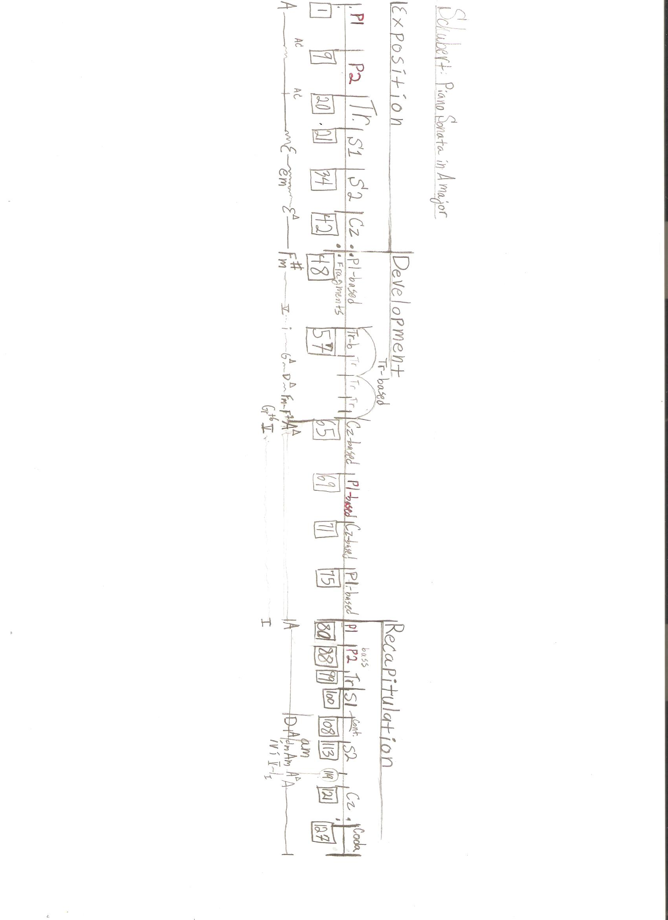

Figure 1.1: The overall form of the Schubert Piano Sonata in A major.

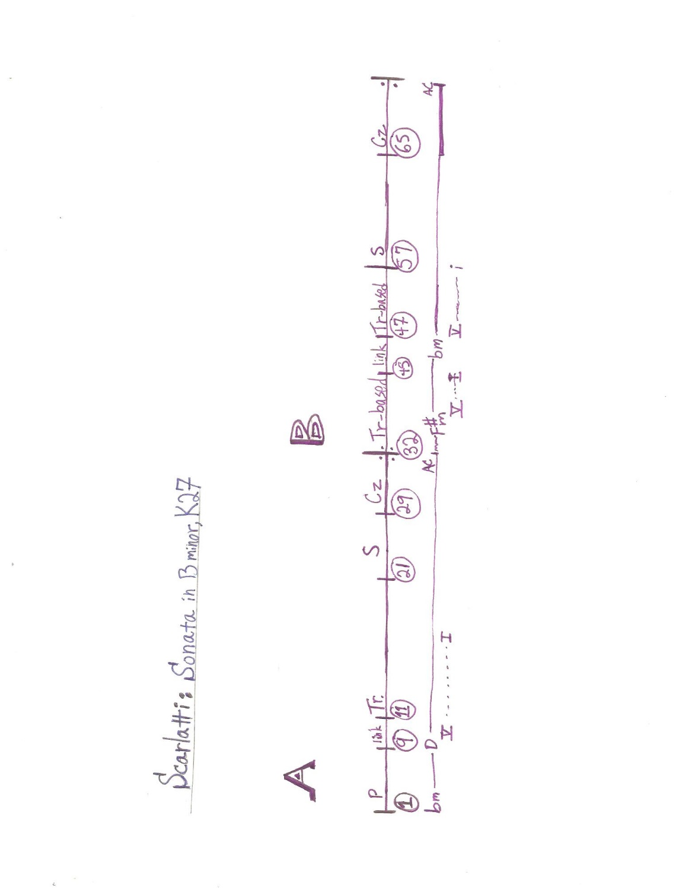

Figure 1.2: The overall form of Scarlatti’s Sonata in B minor.

